Mission Innovation – Hydrogen Sustainability Assessment

**Table of Contents**

1. Introduction 4

2. Sustainability Overview 4

2.1. Sustainability Metrics Specific to Hydrogen Projects from Literature 5

2.1.1. Overview of Hydrogen Sustainability Studies and Methods 5

2.1.2. Common Metrics Found in Literature 8

2.1.3. Sustainability Practice in Industry 8

2.2. Sustainability Organizations and Frameworks 10

2.2.1. Proposed Framework for How to think about Hydrogen Sustainability Metrics 12

2.3. Sustainability Framework Reviewing Approach 12

2.3.1. Economic Objectives 13

2.3.2. Environmental Objectives 13

2.3.3. Technical Objectives 14

2.3.4. Social Objectives 15

2.4. Proposed Sustainability Metrics and Methods for Hydrogen Framework 16

3. Conclusion 19

3.1. Organizations 19

4. Appendix 20

4.1. Economic Metrics 20

4.1.1. Financial performance 20

4.1.2. Market & Industry 22

4.1.3. Resource Efficiency 22

4.1.4. Risk and Security 23

4.1.5. Regulatory compliance 24

4.2. Environmental Metric 24

4.2.1. Resource Use and Pollution 24

4.2.2. Waste and Emissions 26

4.2.3. Greenhouse Gas (GHG) and Climate 27

4.3. Technical Metric 28

4.3.1. Infrastructure and Capacity 28

4.3.2. Efficiency and Performance 29

4.3.3. Technology Readiness 31

4.3.4. Safety and Risk Management 31

4.3.5. Availability and Reliability 32

4.4. Social Metric 33

4.4.1. Community Impact 33

4.4.2. Workforce Development 34

4.4.3. Health and Safety 34

4.4.4. Equality and Fairness 35

4.4.5. Local Development 36

5. References 38

# Introduction

Over the past several years, many countries have announced plans to include hydrogen as a key tool in decarbonization of their economy. Germany, the UK, Netherlands, Chile, Finland, the U.S. and more have not only announced national roadmaps or strategies but have committed to billions of dollars to advancement and deployment of hydrogen technologies. Given this heightened interest in hydrogen and the expected growth in project development to come over the next few decades, one key area of concern that has yet to be addressed is sustainability of hydrogen supply chain infrastructure projects. Whether it’s production, transmission, storage or end use, the sustainability of these projects should be addressed to ensure the project results in a net benefit to society. Sustainability benefits could be realized in numerous ways.

Today, project developers understand very well key economic metrics. Those may include return on investment, payback period, or net present value, to name a few. Technical metrics like efficiency and reliability are also a concern as it directly impacts project economics. Environmental metrics such as reduction in Greenhouse gas (GHG) emissions are another key criterion being evaluated to ensure these projects’ impacts are helping to fight climate change. But what other metrics make a project sustainable? Is it a reduction in waste? Net increase in job creation for the local community? Sourcing critical minerals domestically? Efficiency of energy-intensive processes? These topics are explored in this paper and a framework for considering what sustainability metrics, beyond typical economic and technical metrics, should be applied to hydrogen infrastructure projects to support long-term sustainable clean energy investment will be proposed and discussed here.

# Sustainability Overview

There are numerous certification entities today that furnish some form of sustainability certificates. These are used across a variety of applications such as residential or commercial buildings, communities, and construction methods. Notable certification entities include BREEAM, LEED, and Green Star to name a few. Their ratings systems help project developers design and construct buildings to meet a variety of sustainability metrics that fall under one of four broad objectives, namely: economic, environmental, technical, and social. Examples of metrics may include reduction in carbon footprint or emissions, higher energy efficiency, lower or sustainable material usage, increased biodiversity, increased resilience/reliability, captured benefits of a circular economy, job creation and training, inclusivity of marginalized communities, etc.

These objectives all broadly apply in some form to the hydrogen economy. However, not all the metrics used for non-energy industries are applicable to hydrogen infrastructure projects. Throughout the following sections this paper will explore the metrics relevant to hydrogen projects from the literature and cross reference similar metrics used in practice by the energy and non-energy industries today to ultimately derive a list of metrics to be considered for measuring the sustainability of hydrogen infrastructure projects. This paper also briefly examines some of the self-reported sustainability metrics often cited by industry to understand what is self-reported and why and whether there is merit in adopting these metrics.

## Sustainability Metrics Specific to Hydrogen Projects from Literature

From the literature review, we found that far more studies on general energy sustainability metrics existed than for hydrogen specifically. Many of these are relevant to the research and we will explore them throughout this paper. Hydrogen-specific sustainability papers, however, were very limited but the few that were collected will serve as a starting point to think through how to frame sustainability metrics in a hydrogen context. In the following section we will first explore the metrics and methods used in literature.

### Overview of Hydrogen Sustainability Studies and Methods

In Acar et al. 2019, the proposed framework through which to assess sustainability of hydrogen systems was the “3S approach” (Review and evaluation of hydrogen production options for better environment, 2019). Here the authors define the “3S’s” to be: Source, System, and Service. “Source” is defined as the input source used to generate hydrogen, “System” is the hydrogen system itself, whether that be production, storage, or delivery system and finally “Service” is the end-use which hydrogen is servicing such as power, heating, cooling, etc. For each “S” category above, individual hydrogen systems are evaluated and compared to one another on how sustainable they are by assessing metrics that fit under a broader umbrella of five comparative performance traits: Economic, Environmental, Social, Technical, and Reliability. Below left is an overview of the 3S framework, while to the right are the overall objectives and metrics to be compared.

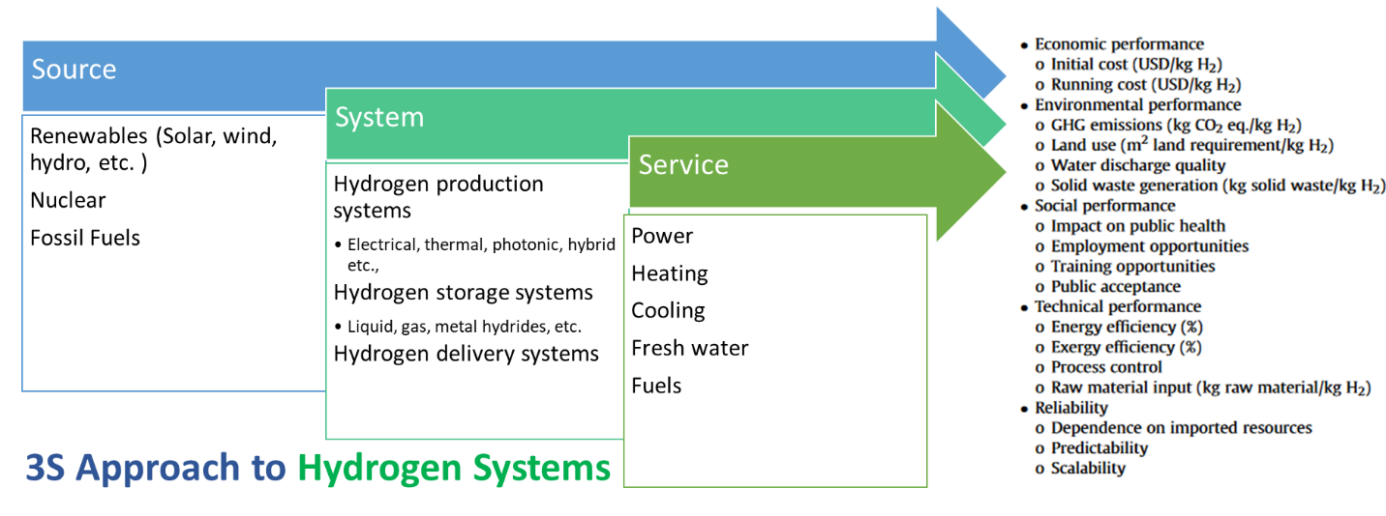

Figure 1. 3S approach to hydrogen energy system.

In two other papers, one by Acar et al.2018 (Sustinability analysis of different hydrogen production options using hesitant fuzzy AHP, 2018) and another by Xiang et al. (Integration and economic viability of fueling the future with green hydrogen: An integration of its determinants from renewable economics, 2021) , a methodology known as Analytical Hierarchical Process (AHP) was used to assess sustainability of varying hydrogen production technologies given four main objectives falling under economic, commercial, environmental, and social adoption. The former study utilized the hesitant fuzzy AHP while the latter utilized the fuzzy AHP. Both are extensions of the AHP methodology, which itself is a multiple-choice decision analysis (MCDA), but the former is used when there is a higher degree of ambiguity among subjective choice preferences, as is often the case in ranking the importance of sustainability metrics. While this method allows the decision makers to better express their assessments linguistically, its shortfall is that subjectivity in the weighting of each sustainability metric persists as it is the decision maker alone who decides the weighting of each metric. The five objectives and their metrics can be found below.

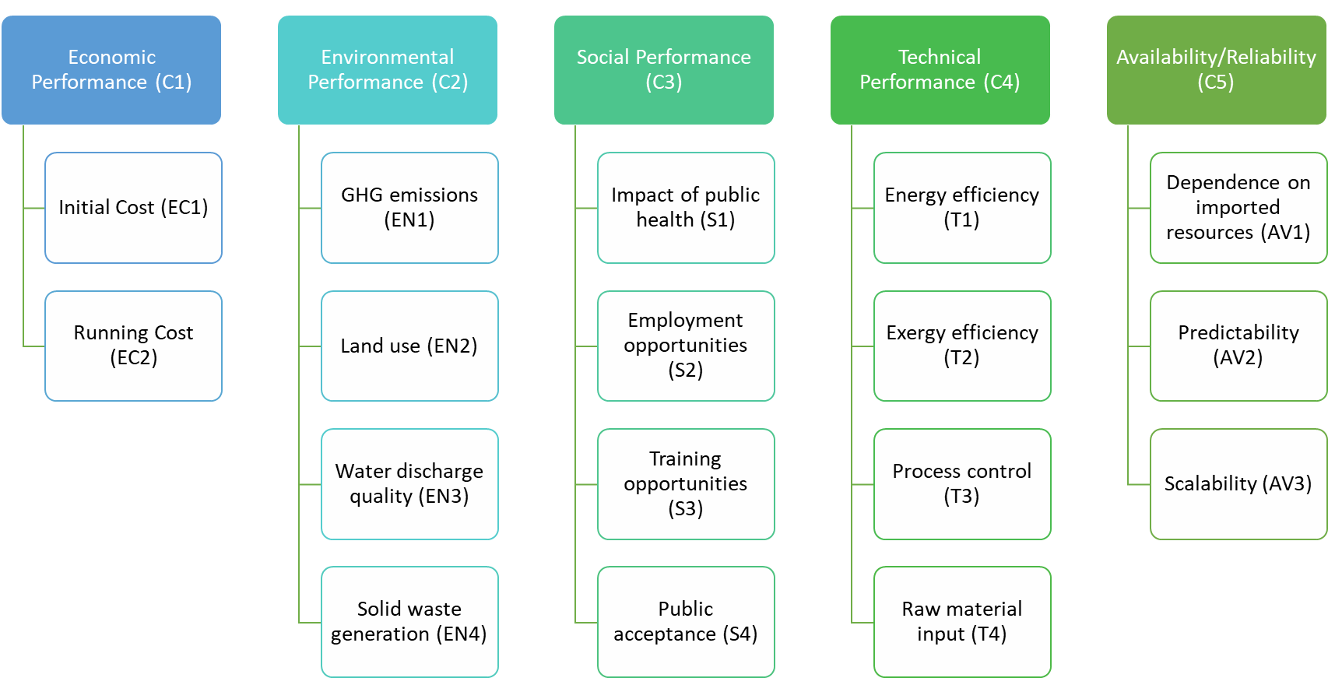

Figure 2. Sustainable hydrogen production criteria.

With this method, what ultimately may provide better results is to decide how to equitably weight each metric such that a hydrogen project’s sustainability is measured on its net impact to the local environment and residents. The impact should be such that all metrics, when taken into consideration, results in a net benefit to all stakeholders.

In Hacatoglu et al. 2016, a sustainability assessment was made comparing two competing systems. The report measured the sustainability of a wind-hydrogen energy system and compared it to a conventional gas-fired system using a novel index which they labeled the Integrated Sustainability Index (ISI) and was developed by the same author a few years earlier (Hacatoglu, 2014). To further elaborate on the ISI, it is an index that “incorporates fundamental thermodynamic, economic, and environmental constraints to combine indicators form multiple dimensions into a single-score evaluation of sustainability”. The broad six categories taken into account include energy efficiency, economic factor, size factor, global environmental impact potential, air pollution potential, and water pollution potential. These categories are then broken down further into 20 unique metrics, but not all equally weighted meaning some are more important to decision makers than others.

Table 1. Categories and sub-indicators for the sustainability assessment methodology.



Figure 3. Sustainability metric literature review for hydrogen industry.

The ISI can also be measured from three different perspectives: the Individualist, Egalitarian, and Hierarchical. The three perspectives help bring a broader perspective to sustainability, taking into account time and space as additional measures. The table below summarizes these perspectives: (e.g. Archetypes) and their unique considerations (Hacatoglu, 2014).

Table 2. Different perspectives for a broader

| **Archetype** | Time | Space | Receptor |
| --- | --- | --- | --- |
| **Individualist** | Short | Local | Humans |
| **Egalitarian** | Long | Global | Ecosystems |
| **Hierarchist** | Medium | Regional | Both |

Though the ISI is a comprehensive index taking into account different perspectives and accounting for various sustainability metrics, the index could be improved on by reducing subjectivity in weighting of the metrics and including metrics that account for social needs in the context of sustainability.

Given the five studies mentioned above, four of the five conducted comparative assessments while one created an integrated sustainability index with which to measure the sustainability of hydrogen projects. These five papers had some overlap in metrics but there were many gaps as can be seen be figure XXX below.

From Figure 3, the top sustainability metrics referenced in the research at least three times were efficiency (energy and exergy), cost (initial and operating & maintenance), public acceptance and scalability. The next section will provide a little more detail on these top metrics and what they are.

Efficiency can be measured on an energy and exergy basis. Costs are typically compared on a least-cost basis taking into account total capital investment and total operations and maintenance costs over the lifetime of a project. Public acceptance is dependent on the public response to the project. Scalability can be measured by the extent or the capacity of the installed facility for addition in future without any major changes needed.

These metrics, while all provide a good baseline to measure sustainability are limited. To develop a more comprehensive framework for sustainability, the overall objectives of reaching sustainability should include additional metrics for each of the objectives of economic, technical, environmental, and social.

The next section will focus on sustainability practices by industry. Though there is not a single agreed-upon framework for sustainability, many publicly traded companies report on their sustainability progress. We will review what is reported and try to assess what can be learned from industry and possibly applied in practice.

### Sustainability Practice in Industry

In March 2022, the SEC has proposed rules that would require companies to disclose climate-related risks that would materially impact their business. While these rules are proposed to be phased in in fiscal years 2023 through 2027, many companies are currently taking the initiative to start reporting on such issues as well as other ESG practices. In this section we review numerous sustainability reports from several of the world’s large hydrogen producers. This list includes Linde, Shell, CP Chem, Plug Power, Bloom Energy, Nel, Linde, Air Liquide, ITM Power, McPhy, and Air Products.

The graphic in Figure 4 shows a summary of reported metrics. While not intended to be comprehensive, it provides insight as to which sustainability metrics and goals are most emphasized by companies today.



Figure 4. (a) Metrics used by industry to evaluate their sustainability index. Most commonly used metrics and their count under the umbrella of (b) GHG reductions, (c) Community engagements, (d) Sustainable economic growth, (e) Employee safety, (f) Diversity and Inclusion, (g) Water conservation and (h) Waste reduction.

Upon reviewing the sustainability reports from these companies, it is important to note that each company not only differed in the metrics reported and the frameworks used to derive these metrics, but also in the depth to which they reported on sustainability metrics. The following paragraphs will just highlight a sample of two companies. The first is Plug Power, a U.S.-based manufacturer of electrolyzers and producer of hydrogen. The second is Air Liquide, a French producer of “grey” (or fossil fuel) hydrogen, and CP Chem, an American petrochemical producer and also a producer and consumer of fossil-based hydrogen.

Plug Power’s sustainability report focused primarily on emissions and water withdrawn. They measured their emissions in accordance with the Greenhouse Gas Protocol. Aside from these two metrics, Plug Power was comparatively light on reporting metrics in other areas of sustainability, though there was mention of their policies concerning health & safety, wellbeing, and employee engagement. Furthermore, Plug Power highlighted their adherence to the Conflict Minerals Rule and made statements on their verification of supply chain partners to ensure a responsible supply chain. Lastly, they rounded out their report with an assessment of risks highlighted by the Task Force of Climate-Related Financial Disclosures (TCFD) framework, their impacts, and mitigation strategies.

Air Liquide, on the other hand, produced an extremely comprehensive 2022 sustainability report. In addition to report on scope 1, 2, and 3 emissions the company also reported on many more sustainability areas such as water consumption by source, discharge into air and water, waste and by-products, human resource indicators like workforce makeup, attrition, and parity and diversity. It was not immediately clear what third-party frameworks were adopted to calculate these metrics aside from using the GHG Protocol for emissions reporting. Lastly, the company reiterated its support and commitment to the UN’s Sustainable Development Goals as well as sustainability frameworks by TCFD, Sustainable Accounting Standards Board (SASB) and Global Reporting Initiative (GRI).

The dramatic difference and depth of metrics reported and frameworks used here are indicative of lack of clear sustainability standards and regulation which is a key hurdle in adopting any sustainability framework.

## Sustainability Organizations and Frameworks

Given the lack of clear regulatory requirements for sustainability metrics, a number of organizations have been formed to assist companies with self-reporting of a wide, diverse set of metrics. These organizations include:

**SASB (Sustainability Accounting Standards Board) -** The International Sustainability Standards Board (ISSB) of the IFRS foundation now assumes responsibility for the SASB standards. These are available for 77 industries and help companies disclose relevant sustainability information to their investors.

**GRI (Global Reporting Initiative)** - Covers more topics such as labor/management relations, occupational health and safety, training and education, diversity and equal opportunity, non-discrimination, and impact to local communities to name a few. Might have some quantifiable metrics. GRI provides standards and guidance for sustainability reporting on economic, environmental, and social impacts. One of the most widely adopted corporate sustainability reporting frameworks globally.

Figure 5. Recommendations and supporting recommended disclosures.

**TCFD (Task Force on Climate-related Financial Disclosures)** -Task Force on Climate Related Financial Disclosures. Suggested recommendations for reporting on relevant metrics that can be put into mainstream financial reports. Focused on the financial sector but relevant across industries. Chaired by Michael Bloomberg.

**CDP (formerly Carbon Disclosure Project)** - Provides a disclosure system for companies, cities, and states to manage environmental impacts, mainly focused on climate change and water security.

**IIRC (International Integrated Reporting Council)** - Calls for integrated reporting across financial and non-financial performance, including sustainability. Provides a principles-based framework.

**DJSI (Dow Jones Sustainability Indices)** - Bechmarks sustainability performance of the largest companies based on RobecoSAM’s Corporate Sustainability Assessment.

**B Corp Certification** – Granted to for-profit companies that meet standards of social and environmental performance, accountability, and transparency. Adminstered by the non-profit B Lab.

**ISO Standards (ISO 14001, 45001, 50001)** - International standards around environmental management, occupational health and safety, and energy management systems.

## Sustainability Framework Reviewing Approach

This section covers the sustainability metrics used within the available sustainability standards. For this section, SASB and GRI’s comprehensive standards were considered and shortlisted as per relevance to energy and infrastructure industry. The approach adopted for shortlisting of these metrics can be seen as following in the illustration.

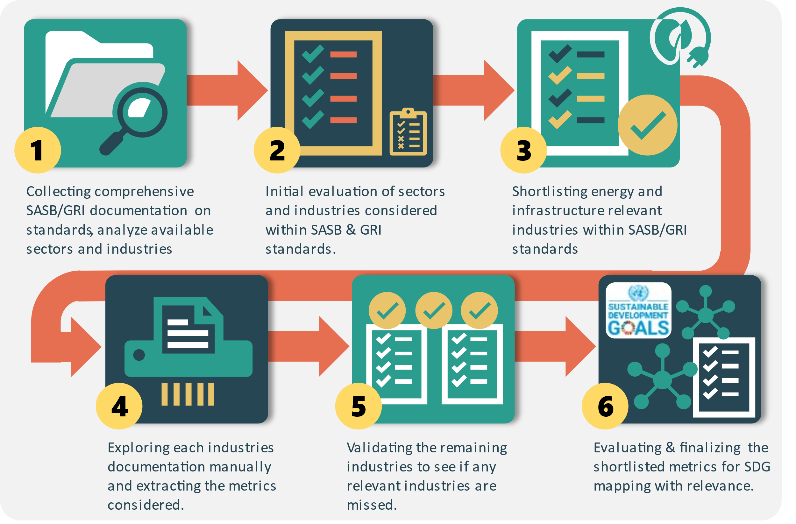

Figure 6. Shortlisting approach for sustainability standards framework – SASB & GRI

The shortlisted metrics are shown below under individual headings.

### Economic Objectives

Table 3. SASB, GRI and SDG overlapping metrics divided into major and subcategories under the broader economic aspect.

| **Aspect** | **Category** | **Sub-Category** | **SASB Metrics** | **GRI Metrics** | **Relevant SDG Goal** |
| --- | --- | --- | --- | --- | --- |
| **Economic** | **Ethics & Governance** | **Business Ethics** | Ethical Business Practices, Competitive Behavior, Fair Labor Practices, Ethical Disclosure & Reporting, Fair Pricing & Disclosure, Ethical Payments & Reporting | Corruption Risk Assessment, Anti-Corruption Training, Confirmed Corruption Incidents, Anti-Competitive Legal Actions, Discrimination Incidents, Political Contributions | Goal 16: Peace and Justice Strong Institutions |
| **Governance** | - | Governance & Employee Diversity | Goal 16: Peace and Justice Strong Institutions |
| **Economic & Financial** | **Financial Health** | Asset Valuation & Investment | Economic Value, Climate Change Financial Risks, Retirement Plan Obligations, Government Assistance, Infrastructure Investments, Indirect Economic Impacts, Local Supplier Spending | Goal 8: Decent Work and Economic Growth, Goal 9: Industry, Innovation, and Infrastructure |

### Environmental Objectives

Table 4. SASB, GRI and SDG overlapping metrics divided into major and subcategories under the broader environmental aspect.

| **Aspect** | **Category** | **Sub-Category** | **SASB Metrics** | **GRI Metrics** | **Relevant SDG Goal** |
| --- | --- | --- | --- | --- | --- |
| **Environmental** | **Air & Climate** | **Emissions** | GHG Emissions, Vehicle Emission Standards, Air Pollution Levels | Direct GHG Emissions, Indirect GHG Emissions (Energy), Indirect GHG Emissions (Other), GHG Intensity, GHG Reduction, Ozone Depletion Sources (ODS) Emissions, Major Air Emissions | Goal 13: Climate Action |
| **Air Quality** | Air Quality | - | Goal 3: Good Health and Well-being, Goal 11: Sustainable Cities and Communities |
| **Water & Waste** | **Water Management** | Manufacturing Water Usage, Water Management, Water Usage & Conservation | Water Withdrawals, Water Discharge, Water Consumption | Goal 6: Clean Water and Sanitation |
| **Waste Management** | Hazardous Waste Disposal, Coal Ash Management, Waste Reduction & Recycling, Hazardous Material Handling | Waste Generated, Waste Diverted, Waste Disposal | Goal 12: Responsible Consumption and Production |
| **Biodiversity & Ecology** | **Biodiversity** | Impact on Flora & Fauna, Biodiversity Impacts | Sites near Protected Areas, Biodiversity Impact, Habitat Protection, IUCN Red List Species Impact | Goal 15: Life on Land |
| **Ecological Health** | Ecological Impacts, Ecosystem Conservation | - | Goal 14: Life Below Water, Goal 15: Life on Land |

### Technical Objectives

Table 5. SASB, GRI and SDG overlapping metrics divided into major and subcategories under the broader technical aspect.

| **Aspect** | **Category** | **Sub-Category** | **SASB Metrics** | **GRI Metrics** | **Relevant SDG Goal** |
| --- | --- | --- | --- | --- | --- |
| **Technical** | **Energy & Resources** | **Energy Management** | Energy Management, Energy Affordability, End-User Energy Efficiency, Energy Grid Stability, Affordable Energy Solutions, Clean Fuel Standards, Emission Reduction & Fuel Management | Internal Energy Consumption, External Energy Consumption, Energy Intensity, Energy Reduction, Product Energy Efficiency | Goal 7: Affordable and Clean Energy |
| **Resource Management** | Ethical & Sustainable Sourcing, Safe Chemical Handling & Storage, GMO Management, Resource Efficiency & Recycling | Materials Used, Recycled Materials, Reclaimed Products | Goal 12: Responsible Consumption and Production |
| **Supply Chain & Sourcing** | **Supplier Management** | - | Environmental Supplier Screening, Supply Chain Environmental Impacts, Social Supplier Screening, Supply Chain Social Impacts | Goal 12: Responsible Consumption and Production, Goal 17: Partnerships for the Goals |
| **Legal & Regulatory** | **Compliance** | Regulatory Compliance, Risk Assessment & Management | - | Goal 16: Peace and Justice Strong Institutions |
| **Efficiency** | **Design Efficiency** | Equipment efficiency | - | Goal 9: Industry, Innovation, and Infrastructure |
| **Others** | **Miscellaneous** | Feedstock Production Impact, Gas Infrastructure Integrity, Mining Waste Management | Significant Spills, Customer Privacy Incidents | Goal 9: Industry, Innovation, and Infrastructure |

### Social Objectives

Table 6. SASB, GRI and SDG overlapping metrics divided into major and subcategories under the broader social aspect.

| **Aspect** | **Category** | **Sub-Category** | **SASB Metrics** | **GRI Metrics** | **Relevant SDG Goal** |
| --- | --- | --- | --- | --- | --- |
| **Social** | **Safety & Health** | **Workplace Safety** | Safety Protocols & Emergency Response, Workforce Health and Safety, Worker Safety & Health, Employee Well-being & Safety, Nuclear Safety Protocols, Incident Response & Prevention | Health & Safety Coverage, Work Injuries, Work Illness, Product Health & Safety Assessment, Product Health & Safety Non-Compliance | Goal 3: Good Health and Well-being, Goal 8: Decent Work and Economic Growth |
| **Product Safety** | Safety Standards for Products | - | Goal 12: Responsible Consumption and Production |
| **Community & Social** | **Community Engagement** | Community Relations, Community Engagement | Community Engagement, Negative Community Impacts | Goal 11: Sustainable Cities and Communities |
| **Rights & Protections** | Indigenous Rights Protection, Security & Indigenous Rights | Indigenous Rights Violations | Goal 10: Reduced Inequality, Goal 16: Peace and Justice Strong Institutions |
| **Labor & Workforce** | **Labor Practices** | Labor Practices, Worker Relations & Rights | Employee Turnover, Full-time vs. Part-time Benefits, Parental Leave, Training Hours, Skill & Transition Programs, Performance Reviews, Governance & Employee Diversity, Gender Salary Ratio, Child Labor Risk | Goal 5: Gender Equality, Goal 8: Decent Work and Economic Growth, Goal 1: No Poverty, Goal 4: Quality Education |

While the metrics provided in the previous section, derived from SASB and GRI sustainability standards, are comprehensive, there are concerns about their suitability for the hydrogen framework. Therefore, we conducted a literature review to identify metrics that align more closely with the specific scope of the hydrogen sustainability framework. The metrics from the literature exhibited similarities to those in the SASB and GRI standards but were better suited to the objectives (economic, environmental, social, and technical) of the hydrogen framework. As a result, we have selected a set of most relevant metrics for each of these objectives, which can be found in Figure XXX. Each of the metrics under the respective objectives have sub metrics that can be calculated as per the guidance available in the Appendix of this document.

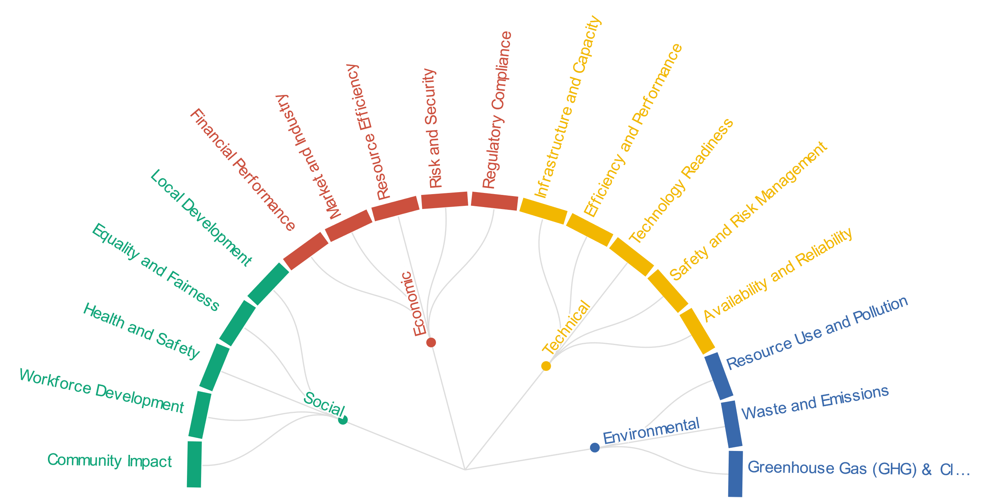

Figure 7. Metrics under the broad categories of economic, environmental, social, and technical.

## Proposed Sustainability Metrics and Methods for Hydrogen Framework

In this section a number of metrics are proposed as key metrics to be considered for hydrogen supply chain projects.

In the table below we outline some proposed metrics and sub-metrics to be considered in the evaluation of the sustainability of a hydrogen project. They are categorized by the four key “objectives” – social, economic, technical, and environmental. We have also referenced what SDG each sub-metric addresses as well as whether the sub-metric was derived from a literature resource (“LR”) or a sustainability standard (“SS”) from frameworks like SASB or GRI.

Table 7. SASB, GRI and SDG overlapping metrics with available metrics in literature for energy and hydrogen sustainability framework divided into major and subcategories under the broader economic aspect.

| **Objective** | **Metric** | **Sub-Metric** | **SDG Goal** | **Source** |
| --- | --- | --- | --- | --- |
| Economic | Financial Performance | Investment Cost | 7 | LR |
| O&M Cost | 7 | LR |
| Payback Period | 7 | LR |
| Net Present Value | 7 | LR |
| Return on Investment | 7 | LR |
| Market and Industry | Industry Expansion | 9 | LR |
| Current market share | 9 | LR |
| Opportunities for private participation | 9 | LR |
| Degree of local ownership | 17 | LR |
| Resource Efficiency | Energy Efficiency | 7,12 | LR |
| Energy Reduction | 7 | LR |
| Raw material input | 12 | LR |
| Risk and Security | Dependence on fossil fuels | 7 | LR |
| Supply and Export Security | 9 | LR |
| Import dependence | 7 | LR |
| Availability of primary energy supply | 7 | LR |
| Risk Assessment & Management | 16 | LR |
| Regulatory Compliance | Legal regulation of activities | 16 | LR |
| Government's supportive energy policies and regulations | 7 | LR |
| Compliance with international obligations | 17 | LR |
| Leveraging energy for national development programs. | 7 | LR |

Table 8. SASB, GRI and SDG overlapping metrics with available metrics in literature for energy and hydrogen sustainability framework divided into major and subcategories under the broader environment aspect.

| **Objective** | **Metric** | **Sub-Metric** | **SDG Goal** | **Source** |
| --- | --- | --- | --- | --- |
| Environmental | Resource Use and Pollution | Water Pollution | 6 | LR |
| Land Pollution | 15 | LR |
| Noise Pollution | 11 | LR |
| Air Pollution | 11 | LR |
| Consumption of natural resources to exploit energy | 12 | LR |
| Waste and Emissions | Amount of non-recyclable waste | 12 | LR |
| Waste Generated | 12 | LR |
| Waste Diverted | 12 | LR |
| Waste Disposal | 12 | LR |
| Significant Spills | 15 | LR |
| [Greenhouse Gas (GHG) and Climate](#_Greenhouse_Gas_(GHG)) | GHG emissions | 13 | LR |
| Indirect GHG Emissions (Energy) | 13 | LR |
| Indirect GHG Emissions (Other) | 13 | LR |
| GHG Intensity | 13 | LR |
| GHG Reduction | 13 | LR |

Table 9. SASB, GRI and SDG overlapping metrics with available metrics in literature for energy and hydrogen sustainability framework divided into major and subcategories under the broader technical aspect.

|  |  |  |  |  |
| --- | --- | --- | --- | --- |
| **Objective** | **Metric** | **Sub-Metric** | **SDG Goal** | **Source** |
| Technical | Infrastructure and Capacity | Current Installed Capacity | 7 | LR |
| Rated capacity | 7 | LR |
| Compatibility with existing infrastructure | 9 | LR |
| Availability of local skill and resources | 8 | LR |
| Degree of local ownership | 17 | LR |
| Efficiency and Performance | Conversion system efficiency | 7 | LR |
| Distribution system efficiency | 7 | LR |
| System Efficiency | 7 | LR |
| Capacity Factor | 7 | LR |
| Scalability | 9 | LR |
| Technology Readiness | Technology Readiness Level (TRL) | 9 | LR |
| Localizing technology and technical knowledge | 9 | LR |
| Safety and Risk Management | Safety | 16 | LR |
| Risk | 16 | LR |
| Safety of devices and technology | 9 | LR |
| Compliance with international obligations | 16 | LR |
| Legal regulation of activities | 16 | LR |
| Availability and Reliability | Lifetime and reliability of systems | 7 | LR |
| Annual resource availability duration | 7 | LR |
| Curtailments / Energy not served | 7 | LR |
| Weather and climate condition dependence | 13 | LR |
| Availability of primary energy supply | 7 | LR |

Table 10. SASB, GRI and SDG overlapping metrics with available metrics in literature for energy and hydrogen sustainability framework divided into major and subcategories under the broader social aspect.

|  |  |  |  |  |
| --- | --- | --- | --- | --- |
| **Objective** | **Metric** | **Sub-Metric** | **SDG Goal** | **Source** |
| Social | Community Impact | Social acceptability | 11,16 | LR |
| Public Acceptance | 16 | SS |
| Cultural Preservation | 11 | LR |
| Conflict with other applications | 16 | LR |
| Negative Community Impacts | 11 | SS |
| Workforce Development | Job creation | 2,8 | LR |
| Education Opportunities | 4 | LR |
| Training Opportunities | 8 | LR |
| Workplace practices | 8 | LR |
| Gender Impact | 5 | LR |
| Health and Safety | Health Impact | 3 | LR |
| Safety & Security | 16 | LR |
| Work Injuries | 8 | LR |
| Work Illness | 3 | LR |
| Employee Well-being & Safety | 3 | SS |
| Equality and Fairness | Fairness in Workplace | 8,10 | LR |
| Discrimination Incidents | 5 | SS |
| Child Labor Risk | 8 | SS |
| Governance & Employee Diversity | 5 | SS |
| Gender Salary Ratio | 5 | SS |
| Local Development | Benefited residents | 1,8, 11 | LR |
| Rural Development | 1,2 | LR |
| Local development | 11 | SS |
| Indigenous Rights Violations | 16 | SS |
| Community Engagement | 11 | SS |

Note: SS – Sustainability Standard. LR – Literature Resource

To establish sustainability standards within a particular industry, it's crucial to customize the framework to align with that specific industry's characteristics and practices. The measurement and calculation of qualitative metrics for the oil and gas industry, for instance, would naturally differ from those used in the renewable energy sector. Therefore, to enhance comprehension and practicality, it is essential to define a system boundary before implementing the standard. This boundary serves the purpose of clearly outlining the study's scope and the elements it encompasses. Tools to Measure and Monitor Sustainability Metrics and Progress

# Conclusion

This paper first outlined some of the major metrics considered today, when evaluating sustainability of hydrogen projects. These metrics are currently limited to ones that are economic, technical, or environmental in nature such as return on investment, energy efficiency, greenhouse gas emissions, or water usage. There is a need to expand the scope of sustainability metrics to include metrics specific to social welfare, diversity, and inclusion, for instance.

## Organizations

* NEPA
* EPA
* OSHA
* Air emissions
* Land usage permitting
* Water permit/rights
* SANDIA researcher – authority jurisdiction (Considerations in Permitting, 2023) – see (LaFleur, 2023)
* API maybe. Perhaps a component within NEPA

reviews commons sustainability metrics that have been used in hydrogen infrastructure projects.

# Appendix

## Economic Metrics

### Financial performance

#### Investment Costs

The formula to compute investment cost can be straightforward and depends on the specific project or initiative being evaluated. Generally, it can be expressed as:

This includes all the one-time upfront costs associated with the project. It typically consists of expenses like purchasing equipment, construction, installation, and any other initial investments. CapEx is often represented as a lump sum or a series of payments over time.

#### Operating Costs

An organization can calculate operating costs as cash payments made outside the organization for materials, product components, facilities, and services purchased.

Services purchased can include payments to self-employed persons, temporary placement agencies and other organizations providing services. Costs related to workers who are not employees working in an operational role are included as part of services purchased, rather than under employee wages and benefits.

Operating costs can include:

1. Property rentals
2. License fees;
3. Facilitation payments (since these have a clear commercial objective);
4. Royalties;
5. Payments for contract workers;
6. Training costs, if outside trainers are used;
7. Personal protective clothing.

##### Fixed Costs

Fixed costs are expenses that do not change significantly with variations in production or business activity. These costs remain relatively stable over time. Examples include rent or lease payments, salaries of permanent employees, insurance premiums, and depreciation of assets. Fixed costs are typically incurred even if production or business activity temporarily ceases.

##### Variable Costs

Variable costs are expenses that fluctuate in direct proportion to changes in production or business activity. These costs increase as production or activity levels increase and decrease as production or activity levels decrease. Examples of variable costs include raw materials, direct labor, utilities directly related to production, and sales commissions.

#### Payback Period

The payback period is a financial metric used to evaluate the time it takes for an investment to generate an amount of income or cash equivalent to the initial cost or investment outlay. In other words, it measures the length of time it takes to recoup the initial investment from the cash flows generated by the investment.

The formula to calculate the payback period is quite simple:

#### Net Present value

Net Present Value (NPV) is a financial metric used to assess the profitability of an investment or project by comparing the present value of expected cash inflows with the present value of expected cash outflows. NPV helps determine whether an investment is likely to generate a positive return and by how much.

The formula to calculate NPV is as follows:

= Net Present Value

= Cash flow during a specific period t

= Discount rate, which represents the required rate of return or the cost of capital

= Time period (usually in years)

= Initial investments cost (usually occurring at time t = 0)

#### Return on investment

Return on Investment (ROI) is a financial metric used to assess the profitability and efficiency of an investment. It measures the gain or return generated from an investment relative to its cost. ROI is expressed as a percentage and is widely used in business and finance to evaluate the performance of various investments, projects, or initiatives.

The formula to calculate ROI is as follows:

Where,

"Net Gain from Investment" refers to the total income or profit generated by the investment.

"Investment Cost" represents the total cost or initial outlay of the investment.

### Market & Industry

#### Industry Expansion

The mean annual growth rate of an investment over a specified period of time longer than a year[1].

#### Current market share

Market share of the company can be calculated as following:

#### Opportunities for private participation

Qualitative metric, depends on multiple factors can be defined as the number of available opportunities for participation.

#### Degree of local ownership

Local ownership can be tabulated as under:

Local Ownership: The sum of shares, equity, or control held by local stakeholders.

Total Ownership: The total sum of all shares, equity, or control in the business or project.

### Resource Efficiency

#### Energy Efficiency

The above formulae is used to calculate overall efficiency. It can be applied to other processes as well.

#### Energy Reduction (ER)

It can be calculated as below:

Where,

Initial Energy Consumption: The amount of energy consumed before implementing energy-saving measures.

Final Energy Consumption: The amount of energy consumed after implementing energy-saving measures.

#### Raw material Input

Raw material input can be calculated as the sum of the total raw material used.

### Risk and Security

#### Dependence on fossil fuels

To calculate dependence on fossil fuels, you can use a simple formula:

Fossil Fuel Energy Consumption: The amount of energy consumed from fossil fuels.

Total Energy Consumption: The total energy consumption from all sources.

#### Supply and Export Security

Supply and export security assesses the reliability of energy supply sources and the potential impact of energy exports on an entity's economy. It may be calculated based on a risk matrix for the bill of components or raw material and their supplier countries or regions.

#### Import dependence

Energy Imports: The total amount of energy imported.

Total Energy Consumption: The total energy consumption from all sources.

#### Availability of primary energy supply

This metric may involve various indicators and assessments, but a simplified formula could be:

Where,

Available Primary Energy Reserves: The estimated reserves of primary energy sources.

Annual Primary Energy Consumption: The total consumption of primary energy sources in a year.

A higher index value suggests better availability.

#### Risk Assessment & Management

Risk assessment can be performed using a risk matrix generated for the potential risk in the supply chain or production. These can be defined as low, medium and high depending upon the sources and other factors.

### Regulatory compliance

#### Legal regulation of activities

It is a qualitative measure.

#### Government's supportive energy policies and regulations

It is a qualitative measure.

#### Compliance with international obligations

This metric doesn't have a mathematical formula. It involves examining a country's or entity's participation in international agreements (e.g., Paris Agreement, Kyoto Protocol) and assessing their efforts to meet the obligations outlined in those agreements.

#### Leveraging energy for national development programs.

It involves evaluating the impact of energy-related programs and policies on national development outcomes. Indicators like GDP growth, employment rates, and access to energy services may be considered.

## Environmental Metric

### Resource Use and Pollution

#### Water Pollution

Water pollution can be tabulated using the water quality index (WQI)

Where,

: Weight of the ith water quality parameter (e.g., pH, dissolved oxygen, biochemical oxygen demand)

: Subindex for the ith parameter (calculated based on the parameter's deviation from a standard)

The sum is taken over all relevant water quality parameters.

#### Land Pollution

Land pollution can be tabulated using the contamination index (CI)

Where,

: Concentration of contaminant i in the soil or land

: Area affected by contaminant i

The sum is taken over all relevant contaminants. The Contamination Index assesses the extent and severity of land pollution.

#### Noise Pollution

Common Index: Noise Pollution Level ()[2]

Formula (for ):

Where:

T: Integration time (usually in hours)

L: Noise level at each time step

The integral is taken over the entire measurement period.

represents the equivalent continuous noise level over a specified time period.

#### Air Pollution

Common Index: Air Quality Index (AQI)

Where:

and : AQI values corresponding to the "good" and "poor" air quality levels

and : Concentration breakpoints for different air pollutants

C: Measured concentration of the pollutant

The AQI provides a standardized way to assess air quality based on multiple pollutants.

#### Consumption of natural resources to exploit energy

It can be calculated as under:

Total Resource Consumption: The amount of natural resources used for energy production.

Energy Produced or Generated: The total energy output from the process.

This metric assesses the efficiency of energy production in relation to resource consumption.

### Waste and Emissions

#### Amount of non-recyclable waste

Amount of non-recyclable waste can be calculated as under:

This formula calculates the quantity of waste that is not recyclable, often referred to as residual waste.

#### Waste Generated

Total waste generated can be calculated as under:

This formula calculates the total amount of waste generated, taking into account various categories of waste, including non-recyclable, recyclable, hazardous, and others.

#### Waste Diverted

This formula calculates the quantity of waste that is diverted from disposal in landfills or incineration through recycling, hazardous waste management, or other diversion methods.

#### Waste Disposal

This formula calculates the quantity of waste that is disposed of through methods such as landfilling, incineration, or other forms of waste disposal.

#### Significant Spills

There is no specific mathematical formula for calculating significant spills. The detection and assessment of significant spills typically involve monitoring and reporting incidents that exceed predetermined thresholds for environmental impact, health, or safety.

### Greenhouse Gas (GHG) and Climate

#### GHG emissions

The calculation of GHG emissions involves summing the emissions of various GHGs, often expressed in units of CO2 equivalent (CO2e), to account for their different global warming potentials. The formula for total GHG emissions can be represented as:

Emissions of Each GHG: The quantity of each GHG released (e.g., tons of CO2, CH4, N2O).

Global Warming Potential (GWP) of Each GHG: A factor that represents the warming potential of each GHG relative to CO2 over a specific time horizon (e.g., 100 years).

The result is expressed in , allowing for a standardized assessment of GHG emissions.

#### Indirect GHG Emissions (Energy)

The calculation of indirect GHG emissions from energy sources often relies on energy consumption data and emission factors provided by energy suppliers. The formula can be expressed as:

Where,

Energy Consumption: The total amount of energy consumed from purchased or imported sources (e.g., electricity, heat).

Emission Factor: The emissions associated with each unit of energy consumed (e.g., kg CO2 per kWh of electricity).

This formula quantifies the indirect GHG emissions linked to energy consumption.

#### Indirect GHG Emissions (Other)

Calculating indirect GHG emissions from other sources often involves data collection and emission factor analysis. The formula may vary depending on the specific source of emissions, and it typically involves multiplying activity data by appropriate emission factors.

#### GHG Intensity

GHG intensity is calculated by dividing the total GHG emissions by the relevant activity or output metric (revenues, sales, unit produced)[3]. The formula can be expressed as:

The result indicates how efficiently GHG emissions are associated with a specific activity or output.

#### GHG Reduction

The formula for GHG reduction is calculated by comparing the baseline (pre-mitigation) GHG emissions with the post-mitigation GHG emissions. It can be expressed as:

This formula measures the decrease in GHG emissions attributable to mitigation actions.

## Technical Metric

### Infrastructure and Capacity

#### Current Installed Capacity

The formula is as follows:

Capacity of Each Energy Source: The maximum output or generation capacity of each energy source (e.g., power plants, wind turbines, solar panels) within the area of interest.

#### Rated capacity

The formula for rated capacity is straightforward:

This value is typically provided by the manufacturer or designer of the energy source or facility.

#### Compatibility with existing infrastructure

There is no specific mathematical formula for this metric. It involves a qualitative assessment of how well the new energy project aligns with and can be integrated into the existing infrastructure. Factors such as grid connectivity, voltage compatibility, and infrastructure upgrades may be considered.

#### Availability of local skill and resources

This metric is typically assessed qualitatively, taking into account factors like the availability of a skilled workforce, training programs, local suppliers, and logistical support. There is no specific mathematical formula for this assessment.

#### Degree of local ownership

To calculate the degree of local ownership, you can use the following formula:

Where:

Local Ownership Value: The total value or percentage of ownership held by local entities or stakeholders.

Total Ownership Value: The overall value or percentage of ownership of the energy project or facility.

The result is expressed as a percentage, indicating the share of ownership that is local. These metrics involve both quantitative and qualitative assessments to evaluate various aspects of energy infrastructure and its alignment with local conditions and needs.

### Efficiency and Performance

#### Conversion system efficiency

The formula for conversion system efficiency is:

Where:

Useful Output Energy: The energy output that serves a useful purpose (e.g., electricity generation, mechanical work).

Input Energy: The energy input required to operate the conversion system.

The result is expressed as a percentage, indicating how effectively the system converts energy.

#### Distribution system efficiency

Distribution system efficiency is often calculated as:

Where:

Useful Energy Delivered: The energy delivered to end-users for their intended purposes.

Total Energy Input: The total energy input into the distribution system, which includes losses.

This formula quantifies the efficiency of the distribution process.

#### System Efficiency

System efficiency can be calculated as:

Where:

Useful Output Energy: The energy output that serves a useful purpose.

Total Energy Input: The total energy input into the entire energy system, considering losses in conversion and distribution.

This formula provides an assessment of the overall efficiency of the entire energy system.

#### Capacity Factor

Capacity factor is calculated as:

Where:

Actual Energy Output: The total energy generated during the specified time period.

Rated Capacity: The maximum output capacity of the energy generation system.

Hours in the Time Period: The number of hours in the time period being considered (e.g., a day, a year).

This metric indicates how efficiently a generation system is being utilized compared to its maximum potential.

#### Scalability

Scalability is not typically measured using a specific formula. Instead, it is evaluated based on qualitative criteria, including the ease of replicating or expanding the technology, the availability of necessary resources, and the adaptability to varying conditions and demand.

### Technology Readiness

#### Technology Readiness Level (TRL)

TRL is not calculated using a specific formula but is typically determined through a qualitative assessment.

#### Localizing technology and technical knowledge

There is no specific mathematical formula for assessing the degree of technology localization. Instead, it is evaluated based on qualitative factors

### Safety and Risk Management

#### Safety

This formula quantifies safety by calculating the percentage of safety incidents relative to the total number of activities or operations. A lower Safety Index indicates a safer environment.

#### Risk

Probability of Occurrence: The likelihood that a specific event or hazard will occur.

Impact: The magnitude of the consequences if the event or hazard does occur.

The risk assessment combines these two factors to estimate the level of risk associated with a particular situation.

#### Safety of devices and technology

This formula calculates the percentage of safety features implemented compared to the total possible safety features available in a device or technology. A higher Safety Rating indicates a safer design.

#### Compliance with international obligations

This formula assesses compliance by calculating the percentage of actions or requirements that have been met in accordance with international obligations.

#### Legal regulation of activities

This formula quantifies the level of legal compliance by calculating the percentage of actions or activities that adhere to required legal regulations.

### Availability and Reliability

#### Lifetime and reliability of systems

Lifetime and reliability assess the durability and dependability of energy systems and technologies.

###### Potential Formula (Lifetime):

###### Potential Formula (Reliability):

These formulas quantify the average lifetime and reliability of energy systems based on data from multiple systems.

#### Annual resource availability duration

The formula to calculate the annual resource availability duration can be expressed as:

#### Curtailments / Energy not served

This formula calculates the percentage of energy generated but not delivered due to curtailments.

#### Weather and climate condition dependence

This formula calculates an index that quantifies the reliance of energy generation on ideal weather or climatic conditions.

#### Availability of primary energy supply

This formula quantifies the availability of primary energy sources relative to their consumption.

## Social Metric

### Community Impact

#### Social acceptability

This formula quantifies the level of social acceptability based on the percentage of positive social responses or opinions relative to the total responses.

#### Public Acceptance

This formula quantifies the level of public acceptance based on the percentage of positive public responses relative to the total responses.

#### Cultural Preservation

This formula quantifies the degree of cultural preservation by assessing the percentage of cultural preservation measures that have been implemented.

#### Conflict with other applications

This formula quantifies the level of conflict by calculating the percentage of identified conflicts relative to the total potential conflicts.

#### Negative Community Impacts

This formula quantifies the level of negative community impacts by calculating the percentage of negative impacts relative to the total impacts assessed.

### Workforce Development

#### Job creation

This formula quantifies the impact on job creation by calculating the percentage of jobs created relative to the total project workforce.

#### Education Opportunities

This formula quantifies the availability of education opportunities by calculating the percentage of educational opportunities relative to the total opportunities offered.

#### Training Opportunities

This formula quantifies the availability of training opportunities by calculating the percentage of training opportunities relative to the total opportunities offered.

#### Workplace practices

This formula quantifies the level of positive workplace practices by calculating the percentage of positive practices relative to the total practices evaluated.

#### Gender Impact

Gender impact assesses how an energy project or technology affects gender equality and the inclusion of women in various aspects of the project.

This formula quantifies the gender impact by calculating the percentage of positive gender impact indicators relative to the total indicators evaluated.

### Health and Safety

#### Health Impact

Health impact assesses the effects of an energy project or technology on the physical and mental well-being of individuals and communities.

This formula quantifies the health impact by calculating the percentage of positive health impact indicators relative to the total indicators evaluated.

#### Safety & Security

This formula quantifies safety and security by calculating the percentage of positive safety and security indicators relative to the total indicators evaluated.

#### Work Injuries

This formula calculates the work injury rate per 1,000 work hours, providing a standardized measure of injuries.

#### Work Illness

This formula calculates the work illness rate per 1,000 work hours, providing a standardized measure of work-related illnesses.

#### Employee Well-being & Safety

This formula quantifies employee well-being and safety by calculating the percentage of positive indicators relative to the total indicators evaluated.

### Equality and Fairness

#### Fairness in Workplace

The extent to which employees are treated equally. Percentage of men and women employed.

#### Discrimination Incidents

This formula calculates the discrimination incident rate per 1,000 employees, providing a standardized measure of discrimination incidents.

#### Child Labor Risk

Number of children employed for non-skilled jobs/labor.

This formula quantifies child labor risk by calculating the percentage of child labor risk indicators relative to the total indicators evaluated.

#### Governance & Employee Diversity

Governance and employee diversity evaluate the diversity of employees and governance structures within the organization. Percentage of men and women employed.

#### Gender Salary Ratio

This formula calculates the gender salary ratio by dividing the average salary for women by the average salary for men. A ratio close to 1 indicates pay equity.

### Local Development

#### Benefited residents

This formula calculates the percentage of local residents who have experienced positive impacts or benefits from the energy project. The specific benefits can vary and might include job opportunities, improved infrastructure, or enhanced living conditions.

#### Rural Development

This formula creates a composite index by combining scores related to economic, social, and environmental development. Each of these scores should be calculated separately based on relevant indicators.

#### Local development

Development in the local areas. Investment in local development in Million $.

#### Indigenous Rights Violations

This formula simply counts the number of documented violations of indigenous rights related to the energy project. It's essential to have a clear reporting and documentation mechanism in place.

#### Community Engagement

This formula creates a composite index by combining scores related to the level of community involvement and stakeholder collaboration. These scores should be calculated separately based on specific engagement activities and feedback mechanisms.

# References

*Considerations in Permitting.* **LaFleur, Chris. 2023.** 2023. Fuel Cell and Hydrogen Energy Seminar.

**Hacatoglu, Kevork. 2014.** A Systems Approach to Assessing the Sustainability of Hybrid Community Energy Systems. 2014.

Integration and economic viability of fueling the future with green hydrogen: An integration of its determinants from renewable economics. **Xiang, Huang, et al. 2021.** 2021, Hydrogen Energy.

*Review and evaluation of hydrogen production options for better environment.* **Acar, Canan and Dincer, Ibrahim. 2019.** 2019, Journal of Cleaner Production, pp. 835-847.

Sustainability of a wind-hydrogen energy system: Assessment using a novel index and comparison to a conventional gas-fired system. **Hacatoglu, Kevork, Dincer, Ibrahim and Rosen, Marc. 2016.** 2016, International Journal of Hydrogen Energy.

Sustinability analysis of different hydrogen production options using hesitant fuzzy AHP. **Acar, Canan, Beskese, Ahmet and Temur, Gul Tekin. 2018.** 2018, Hydrogen Energy.

1. https://www.wallstreetmojo.com/market-growth/
2. https://www.castlegroup.co.uk/what-is-leq/
3. https://www.ssga.com/library-content/pdfs/insights/carbon-footprinting-an-anvestor-toolkit.pdf